Visual Studio with RayStation CPython

This document builds upon instructions, including screenshots, that I received from RaySearch support.

Visual Studio is a phenomenal IDE, especially for anything .NET, including pythonnet, the Python module that RayStation scripting examples use for GUIs. You can obviously write RayStation scripts in Visual Studio no matter where Visual Studio is installed, but if you want to use Visual Studio’s debugger—and proper debugging beats just using print statements to inspect variable values at runtime!—then Visual Studio and RayStation must be installed on the same hardware. This means *all* the RayStation servers! We worked hard with RaySearch support and our IS to install Visual Studio on RAYAPP1, RAYAPP2, and RAYAPP3. We have the workloads **ASP.NET and Web Development** (mainly for .NET GUI design) and **Python Development**.

To use Visual Studio’s debugger with CPython, you must make a few more changes on each RayStation server. These changes require admin permissions.

1. Add the following at line 274 of C:\Program Files\RaySearch Laboratories\RayStation 11A-SP1\ScriptClient\connect\connect_cpython.py:

If isinstance(key, dict):

key = str(key)

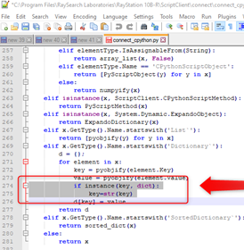

1. Copy C:\Program Files\RaySearch Laboratories\RayStation 11A-SP1\ScriptClient\ScriptClient.dll to C:\Program Files\Python38\DLLs.

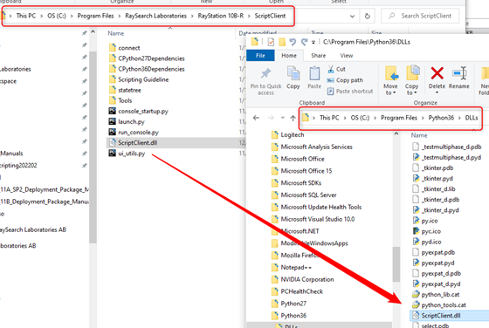

For either IronPython or CPython (please don’t use IronPython!), to connect Visual Studio to RayStation, exactly one instance of RayStation must be running, and your script must reference the ScriptClient DLL and set the RAYSTATION_PID environment variable:

sys.path.append(r'C:\Program Files\RaySearch Laboratories\RayStation 11A-SP1\ScriptClient')

os.environ['RAYSTATION_PID'] = '31348_2'

clr.AddReference('ScriptClient')

You can get the PID from the RayStation console:

